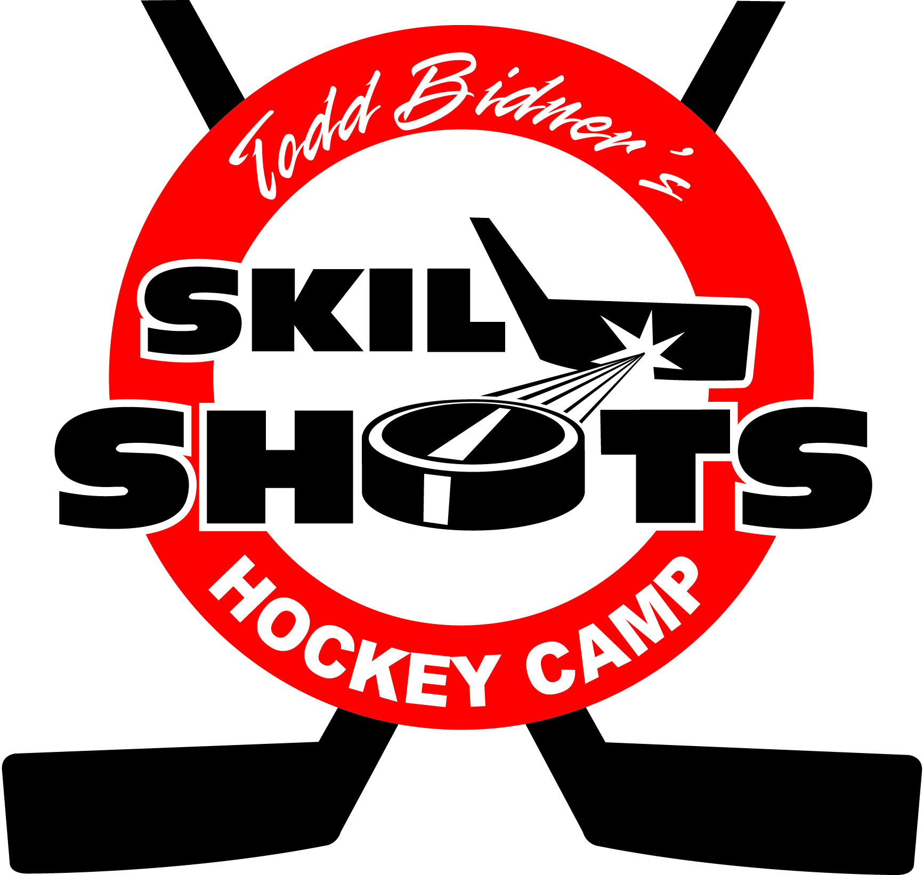 HOCKEY CLINICS

2014 – 2 sessions at Watford Arena
Mondays, 5:00pm-6:00pm - $135/session per player
Session 1: Sept. 29 – Dec 1 (no clinic Oct. 13)
Session 2: Dec 8 – Feb. 23 (no clinics Dec 22 or 29, Feb 16)

Ages 7 -14

(players will be grouped according to ability)

First come, first served

Includes:

POWER SKATING - techniques, stride and edge work
-mechanics of thrust recovery and weight transfer
-agility and turning
-acceleration
-stride lengthening & power stride strength
PUCK SKILLS -stick handling & shooting mechanics
-quick release shots
-puck protection

Todd Bidner’s Bio
BSc(Hons) Sport Science/20years pro
-National hockey League (NHL)
-American hockey league (AHL)
-British Hockey League & European leagues
-Detroit Red Wings Alumni
-27 years hockey school instructor
- Head Coach Lambton Shores Predators
- Asst. Coach OHL (London Knights 2006-07)
- Head Coach, SPHL (Fayetteville 2012)
- Head Coach Senior A Petrolia Squires (2011, 2012)

Sign up by email: score@skillshots.net
Or online @ www.skillshots.net
by phone: 519-869-6757 or 519-331-0011

