**Acquiring your VSC and uploading it into Spordle**

If you have had a VSC for the 2022-2023 and/or 2023-2024 season you can use that **PDF** copy of that. You will need to locate the VSC file and **SAVE as a PDF.** If you require a new VSC please go to step 7

1. Locate VSC in Documents or Downloads folder on Computer
2. Open the file if saved as .docx or .jpeg. If file was saved as **PDF,** skip to step 9
3. When opening the .docx file select **Home** tab select the **Save A Copy**  option
4. Select **PDF** from the drop-down

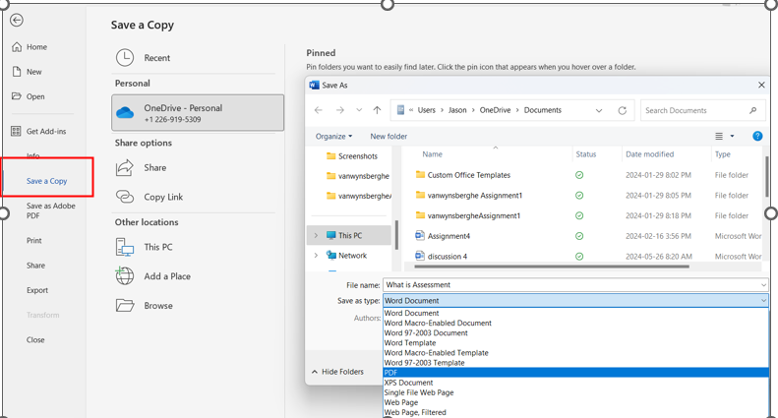

1. Rename the **PDF** as per **OHF guidelines**
2. Go to OHF website [**OHF**](https://www.ohf.on.ca/risk-management/vulnerable-sector-checks/)
   1. To complete the OHF process, you will need your HCR # and the approved VSC or declaration letter from OHF if you have an approved VSC in the last 2 years.
      1. [OHF declaration letter](https://www.ohf.on.ca/media/nohhcaym/ohf-screening-declaration-form.pdf)
      2. HCR # are located your Spordle account profile
      3. Upon logging into your Spordle account (in desktop) select Members and then select your profile

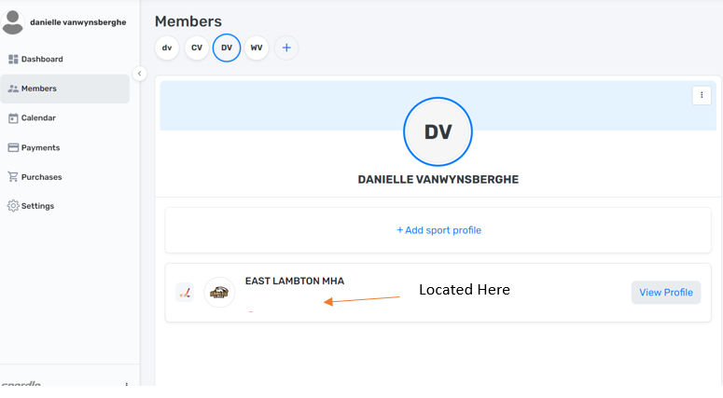

1. If you require a VSC for the 2024-25 season select [OHF VSC Letter](https://www.ohf.on.ca/media/ofonwcwe/ohf-letter-requesting-vulnerable-sector-check.pdf)
   1. You can free type in the boxes proved and select **Save as PDF**, as described above.
   2. You can also print handwrite in the boxes, scan and **Save as PDF.**
2. To submit the VSC locate your appropriate [Police station](https://www.opp.ca/index.php?id=147&lng=en)
   1. Follow the prompts
   2. NB. You will need to have your SIN readily available for this, which can take 2 weeks.
   3. Upon receiving your approved VSC **Save as a PDF**
   4. Upload this **PDF**  to your Spordle account under documents> Other and rename it as per OHF guidelines (VSC with first and last name)
3. Once you have confirmed your HCR # and **PDF** of your letter of declaration or VSC you can start the process. NB, If you can not log in or find your HCR#, please email me, and I can get you the HCR #. You will need to be able to access your Spordle account to upload the VSC
4. Select “[Start the Screening Process"](https://www.ohf.on.ca/risk-management/vulnerable-sector-checks/)
5. Follow the steps, NB you do not need to upload documents to confirm DOB or Residency at this time, just VSC.
6. Following this process you will receive an email of a “Invoice” to the email provided
7. Select OHF Screening Submission Portal

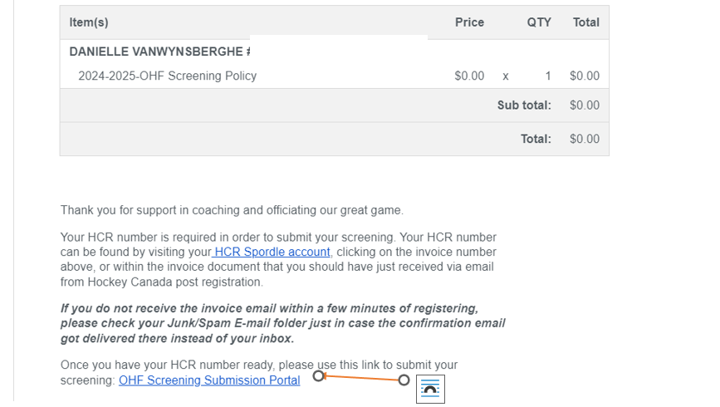

1. Follow the prompts. You should receive an email within 3 days following submission if you have been approved or not