East Lambton Minor Hockey Association
September 10, 2024 - 6:30 pm
Location: Watford Arena – Community Meeting Room

Attending: Adam MacKellar, Brad Rombouts, Tim Lehrbass, Angela Smith, Danielle VanWynsberghe, Brad Blain, Julie Aarts, Jolene Aarts, Greg Kustermans, Dan Davidson, Travis Duncan and Jamie Leyten

Regrets: Julie Hayter, Joel Wilcocks

1.0 Call to Order – 6:33 pm

2.0 Approval of Agenda
MOTION ( Adam and Travis) Approval of this agenda.

3.0 Approval of Previous Minutes
MOTION (Jamie and Greg) Approval of the August 6th, 2024, meeting minutes.

4.0 Business arising from the minutes/ Action Items

ACTION ITEM:

6.0 Treasurer’s Report – Julie Hayter provided detail of the below statements.

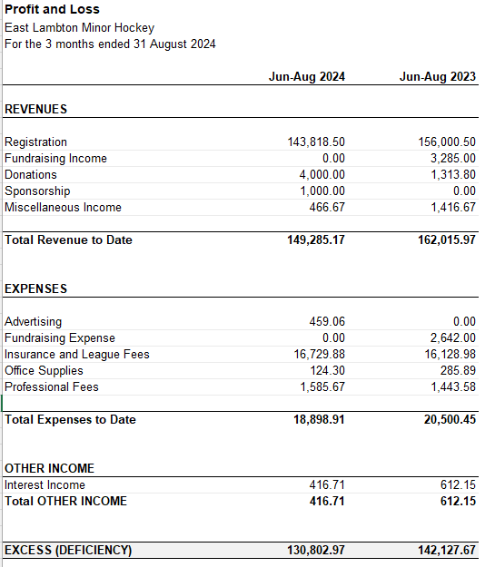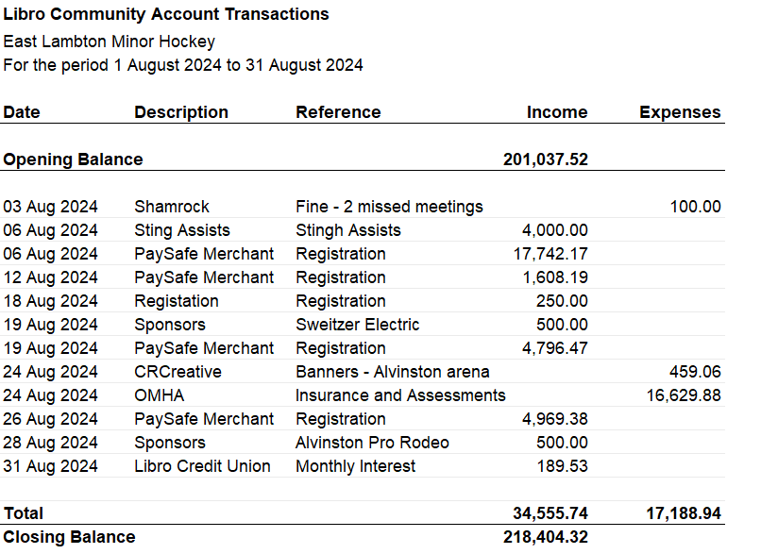

Questions or Comments – Observation that registration is down approx.$10,000+ from last year at this time. Once all registrations have been processed, more clarity on the will be identified.

MOTION (Adam and Angela) to accept the Treasurer’s report.

7.0 League Reports
7.1 OMHA – Brad Rombouts reported:
- Every person volunteering on and off the ice (in contact with young people) whom are rostered, must have the Police Check process completed.
- Other Ontario areas have moved towards U9 is going back to full ice hockey in and are required to count every puck touch for every kid for the season.
- A few new rule changes – you can have 5 coaches on the bench – not six
- Skate blade pop outs = play stop
- Clipping rule – hips and down
- Upgraded words included on the list - “b#$ch” and “p*#sy” - receive 7 games.
- All refs under age of 18 wear green arm band (See OMHA Green Armband Initiative Fact Sheet)

7.2 Shamrock League – Meeting August 12, 2024 – Brad Rombouts reported:
- Discussed U9 games sheet requirements
- South West has a U21 team
- No update on when schedule will be posted.
- AP discussion – no decision yet but some assurance that this will be resolved amicably.
- Level 2 officials can ref in a 4 man officiated game.

7.3 Lambton Middlesex
- Team submissions for local league by the 10th, not later than the 15th
- Lucan hosting a jamboree
- U18 team won’t be able to play head to head
- U9 stays similar to the process last year.
- Coaches and coaching staff must be fully qualified.
- Looking to partner with four counties league
- Need to reply to Mark re: suspensions

Motion: (Brad and Julie )

8.0 New Business
  - U7 Discussion / U7 Extra Ice (?) – Danielle / Adam
No coaches, need to roster U7 in order to go to the jamborees. If anyone knows anyone who wants to coach and would 4 dedicated trainers to attend each individual jamboree. Need for a total of 8 parents volunteers. An email was being sent to the players parent’s group. Not a volunteer credit to help on ice unless receiving the full training for coaching or trainer. Looking to have a parent meeting (face to face). A list of credentials will be compiled in preparation for the meeting. 49 players registered. Due to the high number, request for potential extra ice. There is ice that was given back last year (Sat 2:30 in Watford, Sat. 7am in Alvinston). Planning would need to align to support cohorts of kids if this is offered. Risk would be that there is not enough help for that amount of ice time.
Action: Hold the Saturday ice time(s) until a concrete decision is made (in discussion with the coaches with concrete options to offer – include in the parent meeting) Danielle will communicate with Josie (acting Manager) with the action plan, potential for a board member to meet with the U7 group as early as this Saturday (September 14th @ 11:45am).
  - Minor Hockey Day date – Adam - December 21, 2024. Killer Bees have a home game 2 U18 games that night (1 before, one after) Request not to have with Petrolia due to the crowds. Still require the Minor Hockey Day credit (x3) – (role - organizing raffle, food for teams, silent auction for all OMHA and Silverstick banners). Same day as Watford Silver Stick is same weekend.

  - Team Sizes/ Registration numbers – Adam / Tim -
IP- 48 skaters (see discussion above)

U8/U9- 32 skaters + 4 goalies - Not ideal number – ½ ice for first half of season, need two teams for each side. Last year had 8 U7’s join to support the numbers. Rep – 10 or 11 on rep team with AP options to be utilized each game. Floating goalie option. Keeping in mind 10 and 11 is best for full ice. (team # split - 10, 11, 11) There is interest from a fifth goalie.

U11- 39 skaters + 4 goalies - 4 teams – (team # split – LL -8, 8, AE/Rep- 12, 11)

U13- 34 skaters + 4 goalies - 3 teams (team # split - LL – 12 , AE – 12 , Rep- 10 )

U15- 38 skaters + 2 goalies - 3 teams (team # split - LL –13 , AE –13 , Rep-12) Petrolia and Forest both are potential – waiting to hear back.

U18- 45 skaters + 4 goalies – 3 teams (team # split – LL – 15 (+1), AE -15 (+1), Rep - 15

  - Tuesday Skill Session (?) / Floating Ice – Adam - Tuesday night (7-8:30pm) could have 2 teams rotating through, or shared ice times.
Action: Don’t want to give back ice time! Keep shared practices for onset of the season to establish things and give time to make further decisions, especially when skill sessions required financial feasibility considerations. No floating ice any longer – see above.
  - AE selection committee – Applications due on Sunday, no applicants in yet, will be waiting for first tryouts. Need for Monday selection committee - Brad B., Adam (?), Dan, - will make it work that day if need more. Ang is receiving emails and will chair this committee.
  - IHS - yes/no - 8/10 coaching staff stated they used it to some extent. As long as it in the budget this year to give to coaches then it is supported. Great development and support tool for coaches. All agree to this continuing.
  - Continue jersey bag credit? - The jerseys were returned without issue, which was the outcome hoped for. Keep the jersey bag credit. Option available for older/responsible players to take on this role.
  - Jerseys new one’s arrival and old ones to give away – Use the old jersey’s for practice jerseys. Give them away as appropriate to teams.
New jersey’s September 22, 2024. With exception of 4th U11 team that was added tonight. Name plates will be added before first game this season.
ACTION: Jamie will order more if required, but there should be enough.
  - List of possible coaches for AE and LL – Potential to put together a list of potential coaches for the AE and LL teams – Helps with the “tap on the shoulder” requests in the time crunch.
ACTION: Any names of potential coaching staff the board members have to add to a list, will be welcomed by Tim.
  - Apparel - LINK : East Lambton Minor Hockey – Team Outfitters Sarnia
ACTION: If approved, the online store can go live tomorrow. Coats, wind pants, bags all have original logo for consistency of base gear for the association. Booked for picture day – October 22 and 23rd, 2024 and Team Outfitters will be onsite. Ang to put the link and info on the website and Facebook page. No longer utilizing Herms for apparel.
Approval: Yes
  - Who is informing coaches of player numbers? Tim
  - U13, 15 and 18 Silverstick Registration completed and paid for by Brad Rombouts. U11 first on waitlist LL – many options for tournaments, not sure of the # of teams.
  - Awareness: Forest and Petrolia have approached ELMHA requesting a meeting for potential future amalgamation. The communication is about whether ELMHA wants to be part of the conversation.
  - Selling socks on picture night – add 1 volunteer – 1 credit. – Ang adding to list and communicating

9.0 Next Meeting – October 8, 2024 – Time and Location: Alvinston Arena – 7-9pm

10.0 Adjournment
MOTION (Dan and Danielle ) to adjourn. @ 8:07 pm

