East Lambton Minor Hockey Association
October 8, 2024 – 7-9 pm
Location: Alvinston Arena – Community Meeting Room (Upstairs)

Attending: Brad Rombouts, Joel Wilcocks, Tim Lehrbass, Angela Smith, Danielle VanWynsberghe, Julie Aarts, Jolene Aarts, Dan Davidson, Travis Duncan and Jamie Leyten

Regrets: Julie Hayter, Brad Blain, Greg Kustermans and Adam MacKellar

1.0 Call to Order – 7:03pm

2.0 Approval of Agenda
MOTION (Angela and Julie) Approval of this agenda.

3.0 Approval of Previous Minutes
MOTION (Jamie and Danielle) Approval of the September 10th, 2024, meeting minutes.

4.0 Business arising from the minutes/ Action Items

ACTION ITEM:
Follow up from Matt YMCA – Pricing packages - Will give 25% off, however, there were other situations where 35% discount was provided. Matt came back requesting we add YMCA passes to all registrations as a goal. Not an option at this time.

5.0 League Reports

5.1 Treasurer’s Report – Julie Hayter provided detail of the below statements.

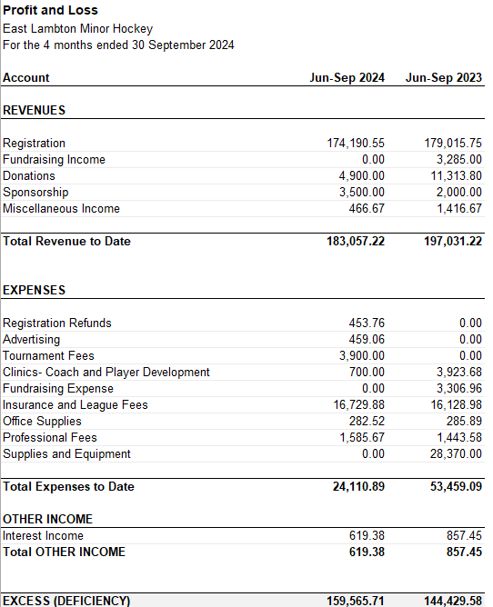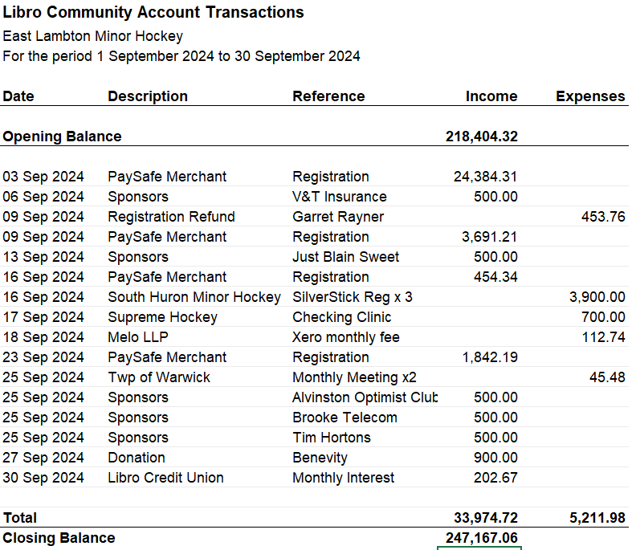

Questions or Comments – None

MOTION (Julie and Travis) to accept the Treasurer’s report.

7.1 OMHA – AP Forms need to be sent in. Brad Rombouts should be signing them as the OMHA rep. No meeting

ACTION: Danielle will send the forms that have been submitted to Brad for review and will be submitted.

7.2 Shamrock League – AP Forms need to be sent in. Brad should be signing them as the OMHA rep. No meeting.

7.3 Lambton Middlesex – Joel reporting - Mooretown U7 wanted in the loop, vote occurring by centers. We will vote “yes”. Joel sent the information out. Question asked about whether we can advocate for LL teams to be placed at the bottom, as this will ensure games are not consistently blow outs. Will be brought forward to the next meeting.

MOTION:

8.0 New Business

  - Coaches meeting update
Positive meeting. Could also have a trainers meeting to support these volunteers. Neck guards must be enforced to be worn on ice at all times. Need to put some processes in place to oversee this being enforced and the seriousness around not abiding by these safety protocols.
LL Tournament - Tim - Comments were made about not having Silver Stick scheduled for all teams (LL).
Action: Further discussion needed re: enforcing neckguards. Board agreed with he decision re: registration for Silver Stick, as it was made in reflection of past years, deadlines for registration, fiduciary responsibility and access to tournaments for each division.
  - Coach and Trainer costs – How can ELMHA support? - Tim
All agree it is imperative to support volunteer coaches and trainers with the costs for the training required. Advocacy to the Armstrong Foundation to reinstate this within their donation. Idea of adding another separate fee, similar to volunteer cheque, however, used for tournament fees and coaching training costs.
ACTION: Adam will talk to Armstrong Foundation to explore reallocation of funds to ensure the coaches and training costs are covered. If they will not do this, all agree that this must be covered via registration costs or increase to volunteer cheques.

  - Registration – What went well/what could be improved? – Tim
If there is a way to navigate the site to include the fundraising fee, that would be helpful. Difficulty with fundraising fees for families with multiple kids registered. Often will require reimbursement when families pay for this for each child. Travis will email Julie the list for fundraising (tickets to be distributed). A great deal of investment into this role.
  - Rostering – What went well / could be improved? - Tim
VSC – There is a complicated process. There is a glitch in the system that does not notify of a problem with the upload of the VSC. Not being approved is the only indicator that something went wrong. Rosters have been approved. Head coach and trainers are rostered for all teams. A great deal of investment into this role
  - Picture Day schedule - Adam
ACTION: Angela will post the schedule tomorrow (October 9, 2024)
  - New Jerseys – name plates - Adam - Jersey’s are ready to go. Name plates can be placed on U13 aged and down as soon as names and numbers are provided to Jamie.
  - Name plates for U7 jerseys - Adam - Many - The U7 aged parents on the board recommended that U7 do not have name plates due to the vast number of ids and the few games played.
  - $300 volunteer cheque collection – when/where? - Adam
Managers to collect these cheques and submitted to Julie by October 22, 2024 to the Tuesday of picture day $300 POSTDATED for March 31, 2025. The tickets will be provided for distribution to families. Notice that children will not be able to go on the ice without the cheques being provided.
  - Sock distribution – when/where? - Adam
New players, regardless of age, get new socks. A list will be provided of new players and distributed to all new players prior to picture day. Socks will be available for purchase at picture days. Socks are $30 a pair.
U9 and U11 jerseys are currently in lockers and can be distributed to the current player immediately. The rest of the jersey’s (U13 to U18) will be available at both picture day. They will be organized by size and each player can take a home and away jersey for free.
  - Minor Hockey Day – No one has stepped up to take on the role to run Minor Hockey Day.
ACTION: The board decided to forgo the Minor Hockey Day events (raffle table and activities in hall) this year due to lack of volunteerism to support the organization and implementation of the day.
  - Future meeting dates and locations - Jolene - Next Meeting- November 5th, 2024 First Tuesday of every month 6:30pm-8:30pm - Alvinston

  - Volunteer Shifts – Alvinston Silver Stick – Travis - If ELMHA needs more volunteer shifts

9.0 Next Meeting – November 5, 2024 – 6:30pm – 8:30pm Location: Alvinston Arena

10.0 Adjournment
MOTION (Angela and Dan) to adjourn @ 8:40 pm

