East Lambton Minor Hockey Association
January 7, 2025 – 6:30-8:00 pm
Location: Alvinston Arena – Community Meeting Room (Upstairs)

Attending: Greg Kustermans, Joel Wilcocks, Tim Lehrbass, Angela Smith, Julie Aarts, Jolene Aarts, Dan Davidson, Travis Duncan, Julie Hayter, Danielle VanWynsberghe and Adam MacKellar

Regrets: Jamie Leyten, Brad Rombouts, Brad Blain

1.0 Call to Order – 6:38 pm

2.0 Approval of Agenda
MOTION (Adam and Greg) Approval of this agenda.

3.0 Approval of Previous Minutes –
MOTION (Dan and Ang) Approval of the December 3rd, 2024, meeting minutes.

4.0 Business arising from the minutes/ Action Items
All Star game Hosting discussion - Dresden will be hosting this All Star Game, no further discussion required.

5.0 Treasurer’s Report – Note, there was an error on last months financial report. Error was revised and is accurate in December’s month end.

Reports in Appendix A and B at bottom of Minutes.

Bench staff training– a couple have been submitted and reimbursed. Team outfitters provided the profits to the club – $683.46. Silverstick 50/50 brought a profit - $1,329. Refund from OMHA - see report for full details.
Horvat donation – $1,850 was provided, as opposed to providing half (50%) registration costs for the U7’s based on numbers provided. Registration has gone up, so this will be impactful (30 new registrations in U7).

Profit loss, reduced expenses from last year.

Ice time over Christmas was rented, which will not be done again next year due to the high level of last-minute cancellations and low use.

No further questions arose re: reports.

Watford Silver stick Account –used for kitchen expenses with bank card to be used for groceries. Sandra McCabe is off the account, and Julie Aarts had been placed on the account. Discussion re: placement of the funds – fundraising income will be placed in the main account, as opposed to increasing the funds in this account.

GIC’s – Julie has set up a plan to have all the GIC maturing at the appropriate timeframes that work best for the organization. Interest made goes into the ELMHA account. GIC all stay at $25,000.

MOTION (Danielle and Joel) to accept the Treasurer’s report.

6.0 League Reports

6.1 OMHA – Dan attended on Brad’s behalf. Limited information at this meeting. Discussion around the severity of the “bad language”, reducing penalties/# of games suspended.
Non-body contact championship proposed/offered.
Vulnerable Persons Check 48,000 – 3,000 still outstanding.
Dresden will be hosting the “B” division All Star Game.

6.2 Shamrock League – No update.

  - Middlesex – Nothing pressing to pass on. U7 playing cross ice.

7.0 New Business

7.1 Coach and Trainer Survey - Tim developed a survey for feedback on the season. If the board is comfortable with the content, it will be sent out quickly. A separate communication or survey will be sent out via email, on the website and Facebook page with information or feedback needed re: boundary removal details.
Action: Danielle made some grammatical revisions and some changes where comments may be helpful in getting clearer feedback on responses where appropriate. Ask question: Are there coaching resources they are using that are not currently funded or offered by ELMHA, what are they? The benefit?
7.2 Mighty Mite Day –
Julie passed everything to Jackie S. who is leading the day for volunteer credit. She has reached out for ice time with Adam and all are confident in the smooth coordination of the day.
7.3 End of Year Banquet
Is scheduled to be held at the Watford Arena Community Center on April 19^{th,} 2025. Venue and food are all booked. Coaches’ deadline for award recipients will be sent to the coaches in the next few weeks. One of the plaques need some upgrade (room for plates).
ACTION: Coaches list will be sent to Greg to get the information out to coaches this month.

7.4 Coaches Selection
With boundary removal, call for applications for coaching selection for Rep teams to be proactive and prepared, to allow for successful candidate announcement in April 2025. Tryouts for AAA, AA and A will be in the Spring.
Action: All in favour for getting the Rep coaching application advertised immediately (as soon as possible). Due date for applications will be February 3rd , 2025, at midnight, with goal to have selection made before March Break.
MOTION: (Travis and Dan) – All in favour – Motion carried.
7.5 Boundary Removal -
A 3-year moratorium on competitive teams – keeps current number of teams in each age group (the teams you have this year, are the teams you have next year – for 3 years – Competitive ONLY). The meeting alluded to an increase in support for small town hockey. Our focus needs to be to maintain a strong association. How do we make decisions on registration with people coming from other areas to play in ELMHA? Team sizes?? Registration costs?? Tryout fees??? Should we be discussing the approach with other associations?
ACTION: Next step is to create some clear guidelines to follow for registration for 2025/26 season. Clarify outstanding questions -
List of questions for Dean:
- How soon can we do tryouts
- Fees, is there going to be any stipulations (charging more for out of area kids?)
- Limit time of registration for local players (can we open registrations up to last years players first for 2 weeks).
- Earliest registration can be opened?
- Clarify “tampering” – is this inclusive of talking to your own catchment kids?
Tim, with a number of board members on the email, will be sent to Dean with the request for answers in writing to share with the whole board. Once these questions are answered, further planning can be completed.
8.0 Next Meeting – February 4th, 2025 – 6:30pm – 8:30pm Location: Alvinston Arena

9.0 Adjournment

MOTION (Travis and Joel) to adjourn @ 8:19pm

Appendix A:

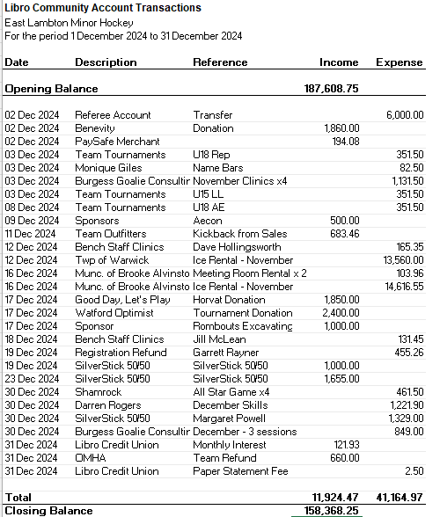

Appendix B:
