East Lambton Minor Hockey Association
December 3, 2024 – 6:30-8:00 pm
Location: Alvinston Arena – Community Meeting Room (Upstairs)

Attending: Greg Kustermans, Joel Wilcocks, Tim Lehrbass, Angela Smith, Julie Aarts, Jolene Aarts, Dan Davidson, Travis Duncan, Julie Hayter, Brad Blain, Brad Rombouts, Danielle VanWynsberghe, Jamie Leyten and Adam MacKellar

Regrets: None

1.0 Call to Order – 6:34 pm

2.0 Approval of Agenda
MOTION (Julie and Jolene) Approval of this agenda.

3.0 Approval of Previous Minutes –
MOTION (Adam and Travis) Approval of the November 6th, 2024, meeting minutes.

4.0 Business arising from the minutes/ Action Items
4.1 - Signing authority was changed successfully.

5.0 League Reports

5.1 Treasurer’s Report –

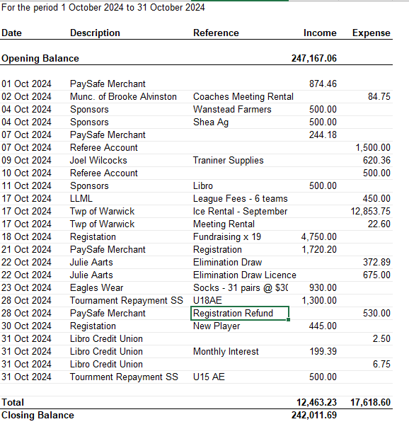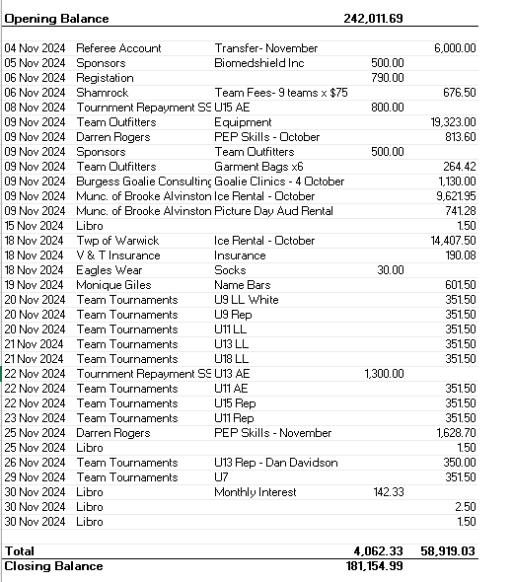

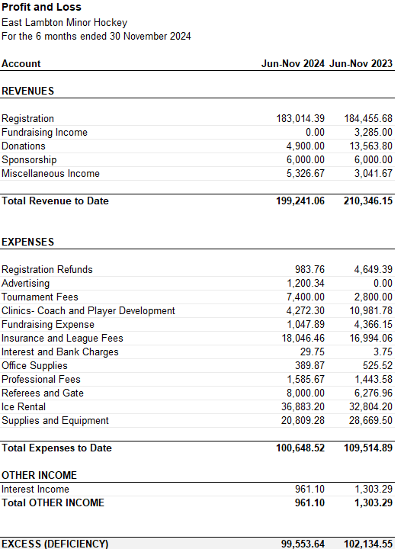

October and November’s treasurer’s report discussed as Octobers was deferred last month. All registration funds have been collected for the 2024/25 year. Sock sales brought in some revenue. All Silver Stick funds were collected. Team Outfitter equipment for new jerseys were the largest expense on October’s report, as to be expected. Same price as Herm’s, but we received them quickly. V and T Insurance were for the insurance coverage for iPad. Name bars have been getting on to jerseys, costs reflected. E-transfer with 2 approvals will work well for efficiency and convenience, small fee which is worth it. Very supportive with the postal strike.

Proft Loss – Less registration refunds this year. Ice rental up $4000 (more ice times rented for tryouts, one extra Watford Ice time this year) . Refs up slightly from this time last year. Notable – coaches and player development – not covered by Armstrong this year. Coaches are not submitting any reimbursement requests as of yet. Communication will be sent as a reminder to submit receipts to Julie for reimbursement. Revenues are located currently in ‘Miscellaneous’, but we will likely need to move that as the number is large. Will get direction from MMP (Auditor).

Watford Silver stick Account – kitchen expenses with bank card to be used for groceries. Need to do paperwork to have another board member added to this account and past board member removed .

GIC’s – Discussion around how long to lock these in due to the unknown hockey landscape. Julie plans to align these better (renewal timeframe, 1 maturing every year). Expiry Dates for 3 GIC’s – 1 – May 2025, 1 – January 2025, 1 - January 2026. End of year, ELMHA will have approx. $130,000(ish). Decision will be to ensure not to raise registration to allow for a natural reduction.

MOTION (Brad and Jamie) to accept the Treasurer’s report.

5.2 OMHA – 7-hour meeting occurred on Saturday, November 30, 2024. Brad was unable to attend that length of a meeting. Adam attended briefly and Tim attended for approx. 3 hours.

5.3 Shamrock League – Season structures have been sent to coaches. U9 Mt Brydges
All Star Game announced. New schedules will be announced between Christmas and New Years.

5.4 Lambton Middlesex – U7 structure was looked at and will be finalized in January 2025 . U18 voted last week – most clubs voted a head-to-head structure. December 7th game on the website must be removed as female and male team cannot play each other.

- New Business

8.1 Silver Stick – Alvinston: Travis has not gone ne in to reimburse registrations yet, will do so. Tournament fees – Registration for Silver stick for the LL teams. Lots of complaints on many aspects. Other Parents complaining that they wanted the opportunity to play in a Silver Stick competition. Option: Do we put a poll on the website re: whether we register teams in Silver Stick. Local League Silver stick – our teams tend to lose (badly). There are options to get your fee back if pulled by posted deadline. AE has very few tournaments available and pre-paid registration decisions were made due to the late decisions around coaching for AE teams.
Volunteer shifts were filled very quickly. 6 shifts (an additional 15 credits available) between kitchen and 50/50 for individual credit opportunities. All is organized and ready to go. Seeding has some minor complaints; Travis followed the Silver stick criteria in seeding teams. Upstairs is rented for the tournament. Feeding every team once, grilled cheese. Request to have the large auditorium washrooms area (not the actual space) to allow for hockey bag storage and use of washrooms.
Watford Silver stick: 50/50 again, if so, someone would need to take care of this (apply for permit, have tickets printed, count money, draw tickets, organize the whole thing). Would need a lead. This would add Donation jar for Silver stick programs, same spot as 50/50. Seven (7) shifts left in kitchen.
Action: Dan will get the lottery license, Brad R. will buy the tickets There will be one draw, held at the end of the second tournament – December 22, 2024. Julie will add 50/50 volunteer shifts to the sign up genius. Clear communication of the remaining volunteer shifts to be posted on website and Facebook page.
8.2 Concussion Protocol Review
Joel changes to parachute guideline Now an NP and doctor can sign off to get you back on the ice. We are currently using the older OMHA form, but question arose about whether we want to keep consistent with OMHA wording or begin to use this inclusion.
Action: Open it up to include the Nurse Practitioner to sign off on return to play protocol.
8.3 All Star Game
Action: All Star game being held in New Hamburg. Cole Pranger (U18), Hunter Talbot (U18), Max Gaspar (U16) Coaches were selected for U16 game Cody, Malcolm and Jackson have been selected as head coach – They picked Tanner Wilson as goalie. $115 per player. ELMHA has historically paid for this. Currently, the only age group with a centre willing to host, is the U18. It is possible that other age groups will have an all-star game, but centres would need to offer.
Action: Discussion to potentially host is on the table for ELMHA. Continue to have this discussion.
  - OHF Meeting “A” Centre Amalgamation - Met with Lambton Shores and Petrolia representatives. Travis and Adam attended on behalf of ELMHA. (See the breakdown of Shamrock team decline over 13 years attached to minutes). Things like boundaries, are still unknown.
Proposed idea: If three organizations reorganized to create an A center, each centre would keep their program (inclusive of name, board, bank accounts, etc.) for a local league only program, each centre would support a “start up fund” to support the development. The “A” centre would have a new name.
Action: Meeting ended with a plan to have representatives go back to their boards to discuss further. At the very least, have a plan in place in the event we have to make a decision quickly. On recently amalgamated centers (ex. South Huron) tab on their website with FAQs, and other information that is helpful to understand the process. This would require an association-wide membership vote. In the event a vote is not in favour, the next vote can’t occur for 2 years. Board supports continued conversations with these centres.

9.0 Next Meeting – January 7, 2025 – 6:30pm – 8:30pm Location: Alvinston Arena

10.0 Adjournment

MOTION (Brad B. and Jamie) to adjourn @ 8:30pm

Appendix: See 8.4 -
