East Lambton Minor Hockey Association
February 4th, 2025 – 8:00-9:30 pm
Location: Alvinston Arena – Community Meeting Room (Upstairs)

Attending: Greg Kustermans, Joel Wilcocks, Tim Lehrbass, Angela Smith, Julie Aarts, Jolene Aarts, Dan Davidson, Travis Duncan, Julie Hayter, Danielle VanWynsberghe Adam MacKellar, Jamie Leyten, Brad Rombouts, Brad Blain

Regrets:

1.0 Call to Order – 8:09 pm

2.0 Approval of Agenda
MOTION ( Travis and Julie) Approval of this agenda.

3.0 Approval of Previous Minutes –
MOTION (Brad and Jamie) Approval of the January 7th, 2025, meeting minutes.

4.0 Business arising from the minutes/ Action Items

5.0 Treasurer’s Report – Decided to put Silverstick money in general account, which is reflected in this report.
-GIC interest came out on January reports.
Profit and Loss, sitting better than we were last year. Ref’s and gates – still money in the account, end of the year it will be emptied.
-Misc. expenses larger due to paying Silverstick registrations for three teams.
-Reminder to collect funds for pins. ($2.50/per pin)
-Watford Silverstick donation will be reflected in February - $10,000

MOTION (Brad B. and Greg) to accept the Treasurer’s report.

6.0 League Reports

6.1 OMHA – Playoffs start this weekend for first round robins. Lots of information coming out regarding next year’s structure and team creation “rules”. Discussion that there will no longer be OMHA or Alliance in the next few years, it will be all OHF.

6.2 Shamrock League – Playoffs also beginning. Appeal made from Eagles – U16 B2 team being moved to lower tier. Will be an All-Star game for all age groups (Dresden hosting)

  - Lambton Middlesex – All Start game in April in Parkhill - $200 per club plus jerseys for each player - $150 per club with a donation made.
Motion to participate (Brad R. and Jolene)

7.0 New Business

7.1 Coaches and Trainers Survey discussion
Action: Defer to next meeting

7.2 Replacement for Marty Swan – Referee Scheduling Role
Discussion around options to approach a few people, as well as put a posting on the ELMHA website to request interest.
Action: Ang will ensure this is posted by tomorrow.

7.3 Spring or Fall Tryouts
Petrolia is planning to have spring tryouts. Lambton Shores is also potentially trying to do in Spring. We need to decide what is on ELMHA’s best interest and when this can be accomplished (ice time, coach availability, etc.) Benefits of Spring tryouts is preparing for next year, AE selection and tournament registration. Cons include not having clear registration numbers to decide on team sizes, lack of ice time in Spring. Recommendation to meeting with Petrolia and Lambton Shores to discuss each centers priorities and plans to guide our decision making. Recommendations to keep things as similar to the way we have always done things, the better.

Action: Meet with Lambton Shores and Petrolia, express interest in Fall tryouts as of now and welcome feedback from our parents over the next few weeks. Status Quo.

7.4 Coaches Interviews
Action: No interviews required
Applications received:
U9 Steve Straatman
U11 Chris McLean
U13 Dylan Gould
U15 Adam MacKellar
U18 Cody Moffatt
Mark Timmermans expressed interest in U11 or to help.

Motion (Brad R. And Travis) to accept coaches.

7.5 “Outside area” players registration discussion/planning
Action: Need more information on tryouts and what other organizations are doing. – Defer to next meeting .
7.6 Eagles Logo and Apparel
Action: Parents have emailed with concerns that Team Outfitters does not provide sizes (x-small) and requested to access rights to logo. Team Outfitters have put X-small sizes on every possible item available in that size. We have committed to Team Outfitters as the contract and they provide the kick back to ELMHA, as well as provide sponsorship. Another concern raised is that Team Outfitters does not add the kids’ names to items. This will be looked into further to see if this is possible. Decision to, in addition to Team Outfitters, allow logo rights to the following businesses, as they requested the rights respectfully: Squirrely Nut and KYIS Embroidery.

7.7 Bar nights/ use of Killer Bees Big Screen for each team once throughout year
Action: Deferred to next meeting
7.8 Doors
Action: Joel looked into the measurements for locker room in Watford arena. $2175/per door to We were permitted to complete the work. The invoice will be provided to the arena for reimbursement. A lock will be purchased for the locker room in Alvinston. Decision to complete work and pay up front and invoice the arena following completion to expedite the process.
9.0 Next Meeting – March 4th, 2025 – 6:30pm–8:30pm Location: Alvinston Arena

10.0 Adjournment
MOTION (Julie and Julie) to adjourn @ 9:30pm

Appendix A:
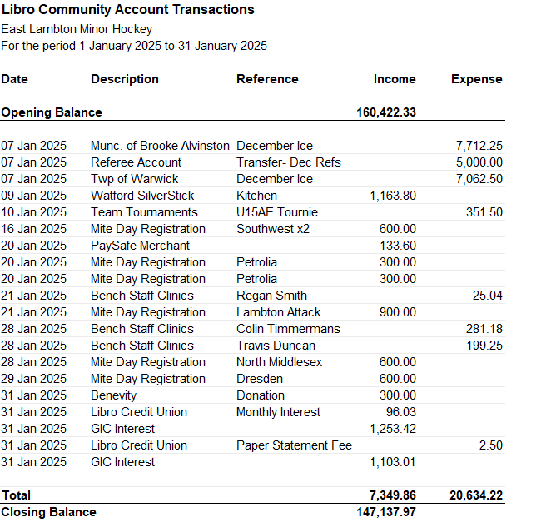
Appendix B:
