East Lambton Minor Hockey Association
August 6, 2024 - 7:00 pm
Location: Watford Arena – Meeting Room

Attending: Adam MacKellar, Brad Rombouts, Tim Lehrbass, Angela Smith, Danielle VanWynsberghe, Joel Wilcocks, Julie Hayter, Brad Blain, Julie Aarts, Jolene Aarts, Greg Kustermans, and Dan Davidson

Regrets: Travis Duncan and Jamie Leyten

- Call to Order – 7:05 pm

Presentation: East Lambton YMCA Matt
Matt provided a brief overview of the East Lambton YMCA and the services offered.
- There are currently 500 members
- Gym, Cardio space, group classes, yoga, gym space rental, senior program and summer day camps. Pilates coming in the Fall
- Childcare available on sire – Times vary.
- Looking to do some cross promotion
- Matt was provided different ways the YMCA could be promoted directly through ELMHA (Jersey Sponsorship - $500 donation, participation in Silverstick and Minor Hockey Day activities)
- Discussed teams that may want to do a team membership, rent the turf areas (includes free weights), running dryland programs (rented space with own instructor, or request a YMCA instructor to facilitate). Matt will put together info on package pricing for teams. This info will be provided to all coaches at the Coaches Meeting, as well as on the ELMHA website.
- Matt provided his card and the interim Fall schedule of programs to the board.
Follow-up: Once pricing is received, this will be shared at the coaches meeting.

2.0 Approval of Agenda
MOTION (Angela and Greg) Approval of this agenda.

3.0 Approval of Previous Minutes
MOTION (Brad B. and Tim L.) Approval of the June 10th, 2024, meeting minutes.

4.0 Business arising from the minutes/ Action Items

ACTION ITEM: Banners in Alvinston – Agreed that that old banners are going to come down at the Alvinston arena to make way for the new East Lambton Eagles banners – list teams on one banner to save space. Put on plastic cardboard material, as opposed to fabric style. Alvinston Arena (Township) committed to completing the work. Old wooden boards will be placed in equipment room. Look at the auctioning the old ones for those who would like it for sentimental value. Can make a minimal profit for the association.

Newest OMHA pictures will be displayed in lobby of Alvinston arena. Believe there is commitment to displaying the old pictures upstairs. Looking at this be completed before the fair / ice goes in.

5.0 Correspondence – No one attended the most recent Shamrock meeting – Fined $100 as it was the second meeting we have missed. Unsure of the fine if a third meeting is missed.

6.0 Treasurer’s Report – Julie Hayter provided detail of the below statements. Not a lot of movement during June and July.

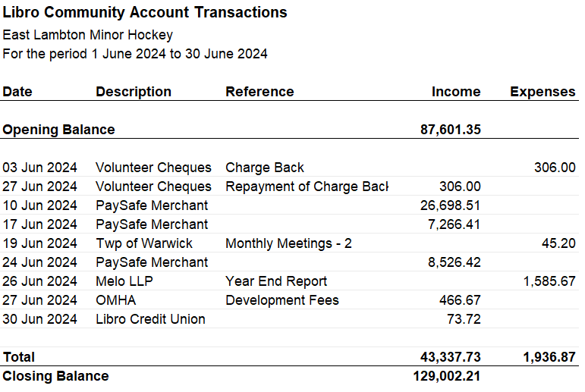

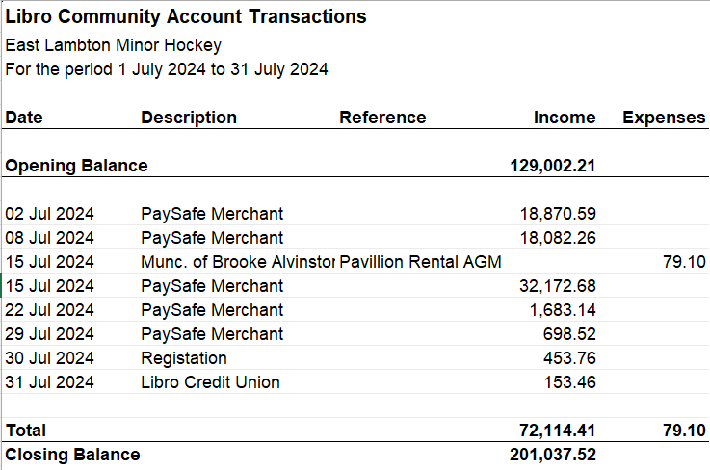

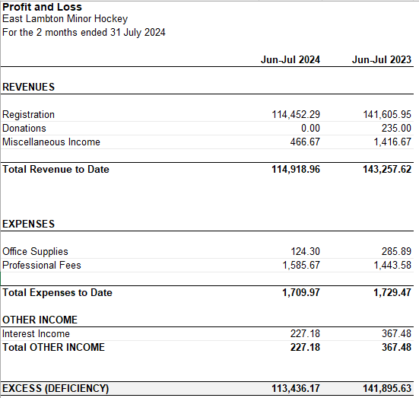

Questions or Comments – None

Sting Assist Ceremony - $4000 – There were 32 organizations who received funds. Julie Hayter attended on behalf of ELMHA.

Email from Libro – E-transfers out can now happen for non-profits with 2 signors. Example why this is needed would be – refunds, payment to referees. Referee e-transfer $1.50 each. No decision made as of yet on whether we utilize this option. Would require the President to approve every e-transfer.

Angela asked if a picture was taken for our website, someone was taking pictures so we can

MOTION (Brad Rombouts and Julie Aarts) to accept the Treasurer’s report.

7.0 League Reports
7.1 OMHA – Season Scheduling is underway. Submission due soon for home game times / days. Adam will submit. All classified as “B” centres.

7.2 Shamrock League – Next Meeting August 12, 2024

7.3 Lambton Middlesex
Tim attended the AGM, elections were held. Changing how stats are taken, things should flow through the Game Sheet app.
Brand Blain, asked about the motion re: local league coming back to their own centre, little to no uptake on this. Season structure – More details to come. Looks like the structure will be similar to past seasons. Break at Christmas will again allow for scheduling to occur.

8.0 New Business
8.1 2024-2025 Season Job List
- See revised Elective role chart. Attached

The following roles Executive roles have changes re: appointment:

Apparel Sales – Angela Smith
Lambton Middlesex Rep – Joel Wilcox
Head Trainer – Joel Wilcox
OMHA and Shamrock Rep – Brad Rombouts
Past President – Adam MacKellar
President – Tim Lehrbass
Secretary – Jolene Aarts
Vice 1 (with no intention for president elect) – Brad Rombouts
Vice 2 – Greg Kustermans

All other roles remain the same. Thank-you to the board members who have invested hours of time in their past roles, in particular Adam MacKellar for his many years as ELMHA President.

ACTION ITEM: Place new volunteer credits up for roles that need to be redistributed as a volunteer credit (receive three (3) credits) for the following roles:
- Mighty Mite Day
- Minor Hockey Day
- Silverstick Kitchen Coordinator (1 per Tourney)

These roles will be included in initial volunteer duties at onset of season.

8.2 Silverstick AE and LL
- Brad R. spoke to last years process for registering for SIlverStick tournaments. This year some processes have changed requiring payment to be made at registration. This would require ELMHA to pay upward to $15,000 upfront. Some risk is associated with this. Investigation on refund policy would be a priority before decision is made. Alternatively, this could result in a team not having a tournament due to not registering in time.
Dan D. and Brad R. seconded proposed motion for AE teams, ELMHA registers/pay upfront (as long as there is a refund policy).

Motion for above (Motion made by Dan D., seconded by Brad R.) : All in favour, Non opposed

ACTION ITEM: Brad will find out what the refund policy is before a decision can be made.

8.3 Ice Schedule
- September 5th, 2024, start date. Pre skates for first 2 skates. Checking clinic will be done twice at onset of season (TBA). Second year Peewee and ALL Bantams are eligible for checking clinic

Week off and on for tryouts (September 14th and 15^{th)} will have home and away games for tryouts vs. Forest. Rep – Sunday night, coaches will be required to post their teams.
AE Tryouts 21st an 22nd with roster decisions made on the Sunday by end of day.
Schedule dependent on Forest schedule to ensure tryout games can be played.
- Question: Dan asked if there was a process communicated on the website for the tryout process. Confirmation that this will happen.

ACTION ITEM:
Adam will get an exact schedule to provide to the board.
Request a registration list shared with board and provided to coaches to ensure communication goes out by coaches.

8.4 Jersey Update - Herms stated they were coming this week. Need confirmation and firm date of Friday, August 9th, 2024.

ACTION ITEM: Dan is calling Herms to firm up details on the long wait for these jerseys. Amy move on if not ready in time for season.

Apparel Options with Matt: Matt provided different styles for logos that could be utilized for Apparel – We would want to ensure that items like coats and bags are all the same logo for precision looking teams. These logos would be for t-shirts, hoodies, etc. Still need to decide.

9.0 Next Meeting – September 10, 2024 – Time and Location: 7pm at East Lambton Community Complex – Meeting Room

10.0 Adjournment
MOTION (Danielle and Joel) to adjourn. @ 8:57pm

